2016 IAOPA World Assembly Speaker Bio’s

**Ian Andrews**

**President, AOPA New-Zealand**



Ian Andrews is president of AOPA NZ, he is a private Pilot with an instrument rating and have been flying since 1986. He is the AOPA representative on many committees, including Medical and Navigation and the introduction of ADSB to NZ.

AOPA NZ works closely with AOPA Australia on matters that are of interest to both countries. He is currently leading the NZ side of a joint approach for the introduction of SBAS into New Zealand and Australia. AOPA New Zealand has 1000 members and represents over 700 pilots with approximately 700 aircraft.

**Mark Baker**

**President & CEO, AOPA (IAOPA)**

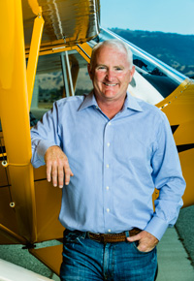Mark Baker has been flying for more than 35 years, using airplanes for fun, commuting, and business. With more than 7,500 hours in the left seat and a commercial pilot certificate with single and multiengine land and seaplane ratings, rotorcraft rating, and type certificates in the Cessna Citation 500 and 525s, Mark’s favorite plane is a Piper Super Cub he’s owned for more than 25 years. Before taking the helm at AOPA, Mark had a distinguished career in top leadership positions at companies including The Home Depot, Gander Mountain, and Orchard Supply Hardware.

[Learn more about Mark](https://www.aopa.org/about/presidents-page).

**Edward Bolen**

**President and CEO, NBAA**

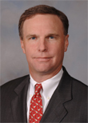Ed Bolen became the president and CEO of the National Business Aviation Association (NBAA) in Washington, DC, on Sept. 7, 2004. Prior to joining NBAA, Bolen was president and CEO of the General Aviation Manufacturers Association (GAMA) for eight years. Bolen joined GAMA in 1995 as senior vice president and general counsel. In 2001, Bolen was nominated by President Bush to serve as a member of the Commission on the Future of the U.S. Aerospace Industry. Bolen was nominated by President Clinton and confirmed by the U.S. Senate to serve as a member of the Management Advisory Council (MAC) to the Federal Aviation Administration (FAA). He chaired the council from 2000 to 2004. Prior to his association career, Bolen was majority general counsel to the Senate Committee on Labor and Human Resources. Bolen received his Bachelor of Arts in economics from the University of Kansas. He is a graduate of the Tulane University School of Law and holds a Master of Laws degree from Georgetown University Law Center. Bolen, a recreational pilot, is also a competitive tennis player and former captain of the University of Kansas varsity tennis team.

**Pete Bunce**

**President and CEO, GAMA**

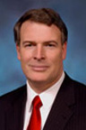 In April 2005, Peter (Pete) Bunce became President and CEO of the General Aviation Manufacturers Association (GAMA) which is headquartered in Washington, D.C. with additional offices in Brussels and Dubai, along with representation in Beijing.  Pete retired from the United States Air Force in March 2005, with his last assignment as the Director of the Air Force Congressional Budget and Appropriations Liaison. During his 26-year Air Force career, Pete flew F-15s and A-10s, while commanding several large operational fighter units. Pete is an active pilot with more than 6,000 hours in military fighter and training aircraft as well as civil piston, turboprop and business jet aircraft. He holds an FAA airline transport certificate and seaplane rating and serves on the board of directors of the Recreational Aviation Foundation, Veterans Airlift Command, America's Warrior Partnership, and the Air Care Alliance. Pete also serves as co-chair of the NextGen Institute and is a member of both the FAA's NextGen Advisory Committee and MITRE Corporation's Aviation Advisory Committee.  Pete and his wife Patty reside in Arlington, Virginia and have six children.

**Steve Creamer**

**Director, Air Navigation Bureau at ICAO**

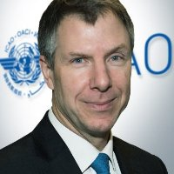Steve Creamer is the Director of the Air Navigation Bureau at ICAO. Previously, Steve has held a number of executive and managerial positions at the U.S. Federal Aviation Administration with over 33 years’ experience in the Air Traffic and International Aviation organizations. They include serving as FAA Regional Office Director for Europe, Africa and the Middle East; and serving as a member of the ICAO Air Navigation Commission. Steve began his career in air traffic operations, eventually managing all Alaskan and North Pacific airspace, pioneering new airspace use techniques that improved capacity and access for all operators. More recently his work has broadened to the international implementation of procedures and technology systems that improve aviation safety, with a careful eye toward building capacity and efficiency.

**Michael Erb**

**Managing Director, AOPA-Germany**

Since 2001. He is the Managing Director of AOPA-Germany. Currently AOPA-Germany´s constituency is 4,000 members, 85 companies, 61 aero-clubs and 39 flight-schools, altogether they represent 18,000 individuals in our industry. So today they are the third-largest AOPA worldwide and the largest AOPA outside of North America.

At AOPA-Germany he leads a team of eight employees and freelancers, he also coordinates the activities of numerous volunteers within their association. At IAOPA Europe he is the Chairman of the Coordination Team and lead the activities of the IAOPA Consortium in the SESAR Project. About his background: In 1992 he started working on his pilot´s license after completing his studies in Business Administration. Now he has a PPL-IR under EASA rules, a CPL-IR under the FAA rules and a sport Pilot License under German National Rules. From 1993-1995 he already worked for AOPA-Germany as Manager Membership Services. In 2000 he received a Doctor´s Degree in Political Sciences for his thesis “General Aviation in the Tension field between Economy and Ecology”.

**Peggy Gilligan**

**Associate Administrator for Aviation Safety**

**Federal Aviation Administration**

Peggy Gilligan became associate administrator for Aviation Safety on January 5, 2009, after serving as the deputy associate administrator in that organization for 14 years. She has been in the Federal Aviation Administration since 1980. As associate administrator, Peggy leads the organization responsible for setting, overseeing, and enforcing safety standards for all parts of the aviation industry—airlines, manufacturers, repair stations, pilots, mechanics, air traffic controllers, flight attendants, and any person or product that operates in aviation. These programs have a direct impact on every facet of domestic and international civil aviation safety. Aviation safety programs are carried out by a workforce of more than 7,000 employees located in the Washington headquarters, regional and directorate offices, and more than 125 field offices throughout the world. The organization’s annual budget is more than $1 billion. 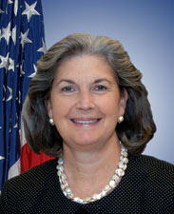

**Tom Haines**

**Senior Vice President, Media and Outreach**

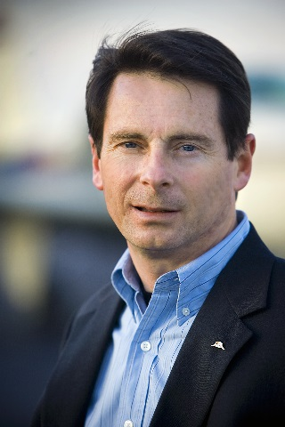An award-winning author, Haines was named editor in chief of *AOPA Pilot*in 1994. Under his leadership, AOPA has expanded its media properties to include *Flight Training* magazine and a host of electronic media. He is the co-anchor of the weekly video magazine AOPA Live This Week. His staff also manages AOPA’s presence at regional fly-ins and air shows.

He holds an MBA and a BA in Journalism. He is a 3,500-hour Commercial pilot with multiengine, instrument, and seaplane ratings, and holds type ratings in Eclipse 500 and Cessna CJ business jets and a second-in-command type rating in the North American B-25. He owns a Beech A36 Bonanza.

**Frank Hofmann**

**IAOPA Representative in ICAO**



Mr. Hofmann has been an active Multi-engine rated General Aviation pilot for 57 years, an aircraft owner for over 45 years, the builder and test pilot of 2 aircraft and is a licensed and practicing aircraft maintenance engineer. During his life-long career in aviation he has been a weather forecaster stationed in the Arctic, a Commanding Officer of an Air Cadet Squadron; a Community College Department Chair of an Aircraft Maintenance program as well as the Chair of their Professional Pilot Training program, and a Project Manager for an aircraft manufacturing and certification project. In his retirement Mr. Hofmann serves as Technical Councilor of the Experimental Aircraft Association, Vice-President of the Light Aircraft Manufacturers Association of Canada, and is the ICAO Representative IAOPA.

**Michael P. Huerta**

**Administrator, FAA**

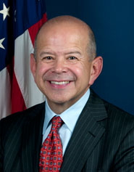Michael P. Huerta is the Administrator of the Federal Aviation Administration. He was sworn-in to office on January 7, 2013 for a five-year term.Huerta is responsible for the safety and efficiency of the largest aerospace system in the world. He oversees a $15.9-billion-dollar budget, over 47,000 employees and is focused on ensuring the agency and its employees are the best prepared and trained professionals to meet the growing demands and requirements of the industry. Huerta also oversees the FAA's multi-billion dollar NextGen air traffic control modernization program as the United States shifts from ground-based radar to state-of-the-art satellite technology.

He holds a bachelor's degree in political science from the University of California-Riverside and a master's in public affairs, with a concentration in international relations from the Woodrow Wilson School of Public and International Affairs at Princeton University.

**John & Martha King**

**Co-chairmen and co-owners of King Schools, Inc.**

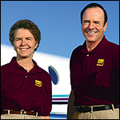John and Martha King´s use of technology and clear, simple, and fun teaching have made aviation knowledge more accessible to pilots throughout the world. After a dismal failure in a business for which they did not have a passion, John and Martha King decided to relax and indulge their love of flying for a while. In the early 1970s, they began teaching flying to mark time while looking for a "serious business." After teaching live seminars for over a decade they put their courses on video and began to revolutionize the flight training industry.

Today their company, King Schools, Inc which started in a spare bedroom in the Kings´ house, operates out of a dedicated complex in San Diego, California that includes a video and software production facility. Over more than 40 years, King Schools has delivered many millions of courses to pilots in training. Through intimate video instruction John and Martha King have taught more pilots than anyone in the history of aviation—for many years teaching more than half the pilots in the United States learning to fly. It's no surprise that pilots throughout the world know John and Martha and regard them as their personal aviation mentors.

**Patrick Ky**

**Executive Director, EASA**

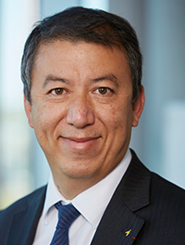Patrick Ky became Executive Director of the European Aviation Safety Agency (EASA) on 1 September 2013. His mission will be to further consolidate the role and responsibilities of the Agency to become a worldwide reference in aviation and to make the European aviation regulatory system a fully consistent, efficient and reliable framework.

In total, Patrick Ky has more than 24 years of work experience in Civil Aviation. A graduate from Ecole Polytechnique and the Civil Aviation Engineering School in France, Patrick Ky also holds degrees in economics from the University of Toulouse and the Massachusetts Institute of Technology. Patrick is married and the proud father of 3 sons. In his leisure time, he plays tennis and enjoys all types of mountain sports (ski, mountain bike, trekking).

**Dr. Fang Liu**

**Secretary General, ICAO**

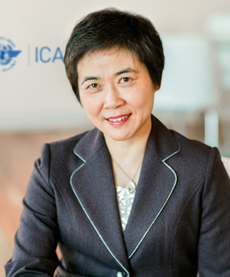Dr. Fang Liu is the Secretary General of the International Civil Aviation Organization (ICAO), having been appointed for a three-year term beginning August 2015. Prior to her appointment as Secretary General, Dr. Liu served for eight years as the Director of ICAO’s Bureau of Administration and Services (ADB). Prior to joining ICAO, Dr. Liu served the General Administration of Civil Aviation of China (CAAC), where over the course of twenty years she successively held the posts of Legal Counsel, Deputy Director, Director and Deputy Director General, Department of International Affairs and Cooperation. Dr. Liu earned a PhD in international law at Wuhan University, China, and a Master’s degree in air and space law at Leiden University, the Netherlands. She is the Director of the Association of Air Law of China and of the Association of Private International Law of China, and has published articles and delivered lectures on a wide range of topics in international air transportation.

**Jiri Marousek**

**Senior Vice President, Marketing**

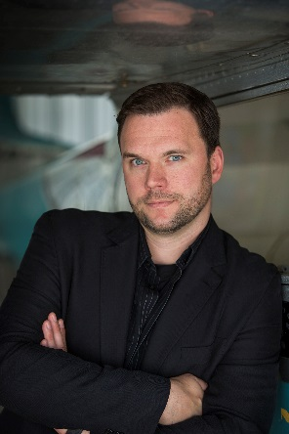Jiri serves as the head of marketing and membership overseeing member services, advertising, partnerships, websites, social media and products. Prior to joining AOPA, Jiri led the global digital marketing for Brand USA. Previous to Brand USA, Jiri served in executive leadership and was a partner at several global advertising agencies, leading digital marketing and innovation for Kellogg’s, LL Bean, Unilever, Nestle, Briggs & Stratton, GE, CycleOps, SC Johnson, and Kohler. Jiri was also the founder of several technology startups working with brands such as Harley-Davidson. He is a motorcycle enthusiast and a pilot that started flying after getting inspired by a fellow rider and pilot to take his intro flight.

**Ken Mead**

**General Counsel**

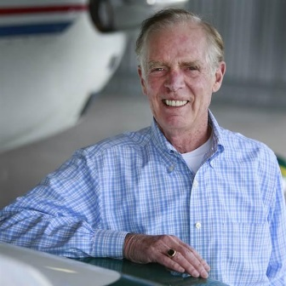Ken Mead has served as AOPA’s General Counsel since 2013 and Board Secretary since 2014. Ken’s staff also manages AOPA’s Legal Services Plan. Before joining AOPA, he was Special Counsel for the law firm of Baker Botts and served under the Clinton and Bush Administrations as Inspector General of the U.S. Department of Transportation, which included the FAA. Ken has testified before the Congress on more than 250 occasions. He is a veteran of U.S. Navy Submarine Service and a student pilot. He earned his J.D. from the University of South Carolina School of Law and is admitted to practice in the District of Columbia and before the U.S. Supreme Court.

**Michelle Peterson**

**VP, Membership Marketing**

AOPA Vice President Michelle Peterson heads a team spanning the areas of membership marketing; direct response fundraising and the AOPA Member Services call center. She is responsible for all marketing related to membership acquisitions, renewals, direct response fundraising, alliances with other organizations, and new market development. Peterson’s primary role includes strategic planning for her areas of responsibility, managing multiple marketing agency and partner relationships, and managing a staff of 26. Michelle also leads the team of customer service professionals who handle a variety of requests, including membership renewals, product upsells, course registrations, information about AOPA products and services, and other membership-related questions, from AOPA members around the world.

**Martin Robinson**

**CEO of AOPA UK and Senior Vice President of International AOPA**

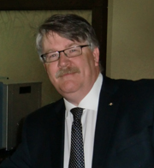

As CEO of AOPA UK and as Senior Vice President of International AOPA, Martin Robinson has experience across safety and business/commercial experience in Europe and the Middle East. He is a Member of the CAA’s Finance Advisory Committee, NATMAC, ASICG, Industry Consultation Body (ICB), EASA Advisory Board and secretary of EGASF. In addition, he is holder of UK and US Pilots’ licenses.

**MELISSA K. RUDINGER**

**VP, REGULATORY AFFAIRS AOPA US**

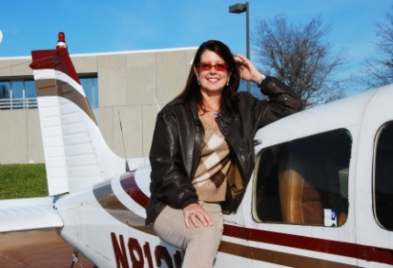

As Vice President of AOPA’s Regulatory Affairs Division, Melissa leads a team of dedicated aviation professionals who advocate for General Aviation interests at the Federal, state and local levels of government on matters affecting airmen, aircraft and air traffic control. The team also represents AOPA's international policy interests at the International Civil Aviation Organization (ICAO), the European Aviation Safety Agency (EASA) and other international regulatory bodies. Melissa has worked for AOPA’s members for 25 years.

A pilot for more than 30 years, Melissa holds a commercial pilot certificate with a lighter-than-air rating and has experience running a local airport business. She has FAA Academy training in Airspace Design and Analysis, Air Traffic Management, Terminal Procedures Development, and Environmental Policy.

**Susanne Schödel**

**Secretary General, FAI**

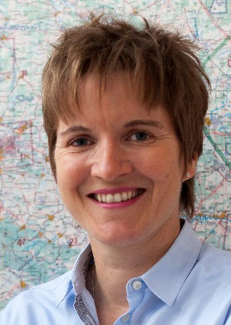Susanne Schödel has been the Secretary General of FAI, the World Air Sports Federation, since 2014. A 44-year-old from Germany, she combines experience in air sports, management of non-profit making organizations and political matters.

Since obtaining her glider pilot’s license at the age of 25, she has perfected her skills to reach the top level in her sport and break world records, while working as a volunteer instructor for youngsters. She has also held a license for powered planes since 1998.

In addition to her activities in air sports, she held several positions in non-profit making organizations, including that of Managing Director of the German affiliate of Susan G. Komen, a major US cancer charity, thus gaining wide-ranging knowledge of administrative matters and extensive experience in work with volunteers. Moreover, she has deep insight into politics and the public sector, having worked for several years for the Ministry of Social Affairs in Hessen, Germany.

**Craig Spence**

**Secretary General IAOPA**

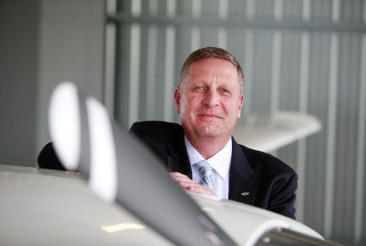Craig Spence joined the Aircraft Owners and Pilots Association in June 2008 as the organizations first Vice President of the newly created Aviation Security Department located within the Government Affairs Division. In October of 2012, Mr. Spence was named as the Secretary General of the International Council of Aircraft Owner and Pilot Associations (IAOPA), directing the activities of IAOPA and representing the interests of general aviation pilots worldwide in 75 affiliate nations, with a combined membership of over 400,000. Craig has been a private pilot for over 33 years and retired from the Air Force Reserves after serving for more than 27 years as a pilot and instructor pilot. He is a Commercial Pilot, with Instrument and multi-engine ratings.