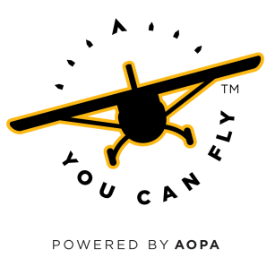
You Can Fly Challenge!
I am pleased to make a commitment to the AOPA Foundation, a 501(c)3 charity, and to support the You Can Fly program that is strengthening general aviation.

My gift of $___________________________ is enclosed. I understand it must be received by the AOPA Foundation before July 25, 2018 in order to be matched by the You Can Fly Challenge.

Signature:________________________________________________ Date:_______________________

Printed name:__________________________________________________________________________

Address:________________________________________________________________________________

__________________________________________________________________________________________

Best phone number:___________________________________________________________________

Email:___________________________________________________________________________________

AOPA member number: ______________________________________________________________

Credit Card No. ___________________________________________________ Exp. Date:________

Please return to: Mark Baker
President & Chief Executive Officer
AOPA Foundation
421 Aviation Way
Frederick, MD 21701

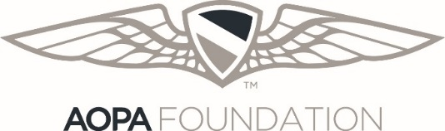
For more information, please contact Mike Tompos, Vice President, AOPA Foundation by calling 301-695-2269 or by emailing mike.tompos@aopa.org.

Thank you!

