VFR Arrival and Departure Procedures
Rocky Mountain Airshow – August 3-4, 2018
Rocky Mountain Metropolitan Airport (BJC)

The Rocky Mountain Airshow will be held at Rocky Mountain Metropolitan Airport (BJC) August 4, 2018. In order to provide a safe environment for flight operations during Airshow use VFR arrival and departure procedures described in this document beginning Friday, August 3 through Saturday, August 4, 2018.

OPERATION / SAFETY NOTE – BJC is in close proximity to Denver International Airport and associated Class B airspace. These procedures do not authorize operations in Class B airspace without specific ATC clearance. Be vigilant in area around BJC due to anticipated heavy traffic.

Air Traffic Control Tower and Airport Information - BJC Airport Traffic Control Tower (ATCT) is open daily 0600-2200 local. Tower may communicate with aircraft by color and type instead of call sign.

All airport taxiways north of Runway 30R/12L, including Taxiway Alpha will be non-movement areas (not controlled by Tower) during the event. Use vigilance when operating in these non-controlled areas. Runway 03/21 will be closed and used for aircraft parking north of Taxiway A. Be sure to check latest NOTAMs prior to operating in area to ensure you have the most up-to-date information.

BJC Airport Scheduled Closures – BJC airport will be closed during various times for Rocky Mountain Airshow. Times below are anticipated closures (in local time). Be sure to check latest NOTAMs prior to operating in the area to ensure you have the most up-to-date information.

CLOSURES:
Friday 12:00-4:00 p.m. Saturday 10:30 a.m – 12:00 p.m.
1:30-3:30 p.m.

ATC Frequencies:
Metro ATIS | 126.25
Metro Clearance | 132.6
Metro Ground | 121.7
Metro Tower (North) | 118.6
Metro Tower (South) | 123.95
Ramp (Parking) Ops | 120.425

Additional frequencies may be used as traffic dictates.

Class B Airspace Mode C Veil – Denver TRACON authorizes aircraft to deviate from ATC transponder and altitude reporting requirements prescribed in 14 CFR 91.215b(2) within Denver Class B airspace veil area with the following restrictions:
- Valid only during Rocky Mountain Airshow on August 4, 2018.
- Authorization applies to Denver Mode C veil airspace located west of Interstate 25 below 8,000 MSL and in Rocky Mountain Metropolitan Airport Class D airspace.
- The above exemption does not authorize entry into Denver Class B airspace, nor does it authorize deviation from Mode C requirement to operate within Denver Class B airspace.

If you require additional information, contact Denver TRACON at 303-342-1590.

Event Location
The 2018 Rocky Mountain Airshow will be held on BJC airport ramp. All participating aircraft will be parked in either grass or a hard surfaced area on existing ramp area or along Runway 03/21. Detailed aircraft parking instructions are provided in this document after arrival procedures. Bring tie downs and chocks.

Arrival Procedures
Monitor ATIS (126.25) for arrival/departure procedures in use. Separate routings are described for arrivals from north and south.

- All arriving aircraft from north will enter arrival flow at intersection of Interstate 25 and Northwest Tollway. This interchange is approximately 7 miles northeast of BJC. VFR waypoint VPNIC depicts this location. Monitor Tower (North) on frequency 118.6 at least 10 miles from interchange. All aircraft are to enter arrival flow north of interchange on west side of I-25. No shortcuts!

- All arriving aircraft from south will enter arrival flow over intersection of Interstate 70 and Interstate 76 just south of Arvada. VFR waypoint VPINT depicts this location. Monitor Tower (South) on frequency (118.6 or 123.95 as indicated on ATIS) at least 10 miles from interchange. All aircraft are to enter arrival flow south of interchange. No shortcuts!

Runway 30R – 30L Arrival
These are the preferred arrival runways and will be used whenever wind conditions allow. They provide easiest access to Rocky Mountain Airshow event area.

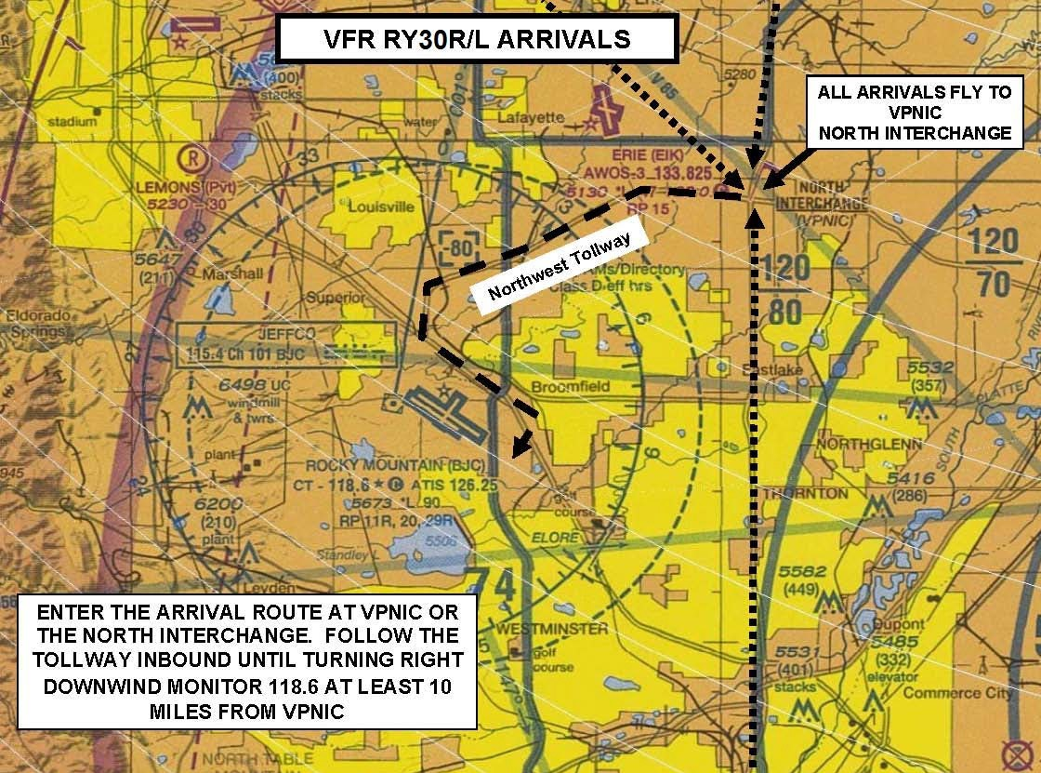
Diagram 1 – BJC Runway 30R/30L VFR Arrival Routing

Arrivals from the North, 30R-30L
- Find last aircraft in line and follow that aircraft.

- All aircraft enter arrival at 6,500 MSL and as close to 90 knots as possible. If you fly faster, allow more room between yourself and aircraft ahead. You will be following that aircraft for at least 5 miles. NO PASSING ALLOWED! NO SIDE BY SIDE! Return to starting point if unable to follow.

- Report your call sign and/or color and type of aircraft to BJC Tower (118.6) when established on procedure and passing over interchange inbound. Example: Metro Tower, blue and white tail dragger over VPNIC with ATIS Charlie.

- Tower will assign landing runway. See diagram and description below for routings.

- Follow tollway inbound (west) until turning right downwind. Keep downwind close to airport over Highway 36.

- Do not begin descent until passing extended centerline of RWY 03/21.

- Be vigilant--possible helicopter traffic operation below your downwind on north side of airport.

- Pay attention to runway you are cleared to land on. Traffic may be inbound for parallel runway.

- After landing, exit the runway as instructed by Tower. Most aircraft can plan to roll out long to exit runway at an intersection PAST runway RWY 03/21. REMAIN ON TOWER FREQUENCY UNLESS INSTRUCTED BY ATC.

- As you enter ramp area, watch for ground handlers to assist you to parking. Ops frequency is 120.425.

Arrivals from the South, 30R-30L
- Find last aircraft in line and follow that aircraft.

- Fly northwesterly after interchange to eastern shore of Standley Lake. Then fly northbound to enter a mid-field left downwind south of airport.

- All aircraft maintain an altitude at least 1,000 AGL while over congested areas. When passing Standley Lake, be established at 6,500 MSL. Maintain as close to 90 knots as possible. If you fly faster, allow more room between yourself and aircraft ahead. You will be following that aircraft for at least 5 miles. NO PASSING ALLOWED! NO SIDE BY SIDE! Return to starting point if unable to follow.

- Report your call sign and/or color and type of aircraft to BJC Tower (118.6 or 123.95 as indicated on ATIS) when established on the procedure and passing over interchange inbound. Example: Metro Tower, red and white Cessna over the VPINT with ATIS Yankee.

- Tower will assign landing runway. Pay attention to the runway you are cleared to land on. There may be traffic inbound for parallel runway.

- After landing, exit runway as instructed by Tower. REMAIN ON TOWER FREQUENCY FOR FURTHER INSTRUCTIONS.

- As you enter ramp area, watch for ground handlers to assist you to parking. Ops frequency is 120.425.

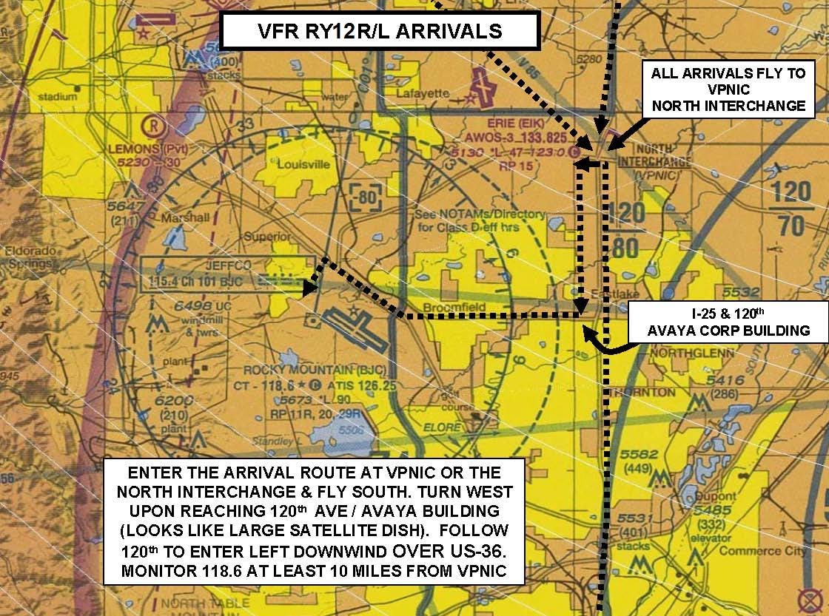
Runway 12L-12R Arrival
Diagram 2 – Runway 12L/12R

Arrivals from the North, 12L-12R

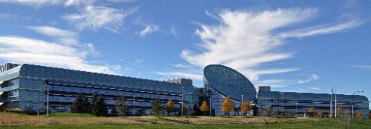
- Follow I-25 southbound. Remain on west side of I-25 to avoid possible conflict with opposite direction traffic on east side of interstate.
- Turn west at 120th Ave. This road leads directly to center of BJC airport. It is easily identifiable by a large corporate building (DigitalGlobe) that looks like a huge satellite antenna dish. Continue to follow 120th Ave. inbound until turning left downwind. Keep downwind close to airport over Highway 36.

- Report your call sign and/or color and type of aircraft to BJC Tower (118.6) when established on the procedure and passing over interchange inbound. Example: Metro Tower, red and white Cessna over VPNIC with ATIS Yankee.

- Maintain 6500 MSL until past centerline RWY 03/21.

- Be vigilant--possible helicopter traffic operation below your downwind on north side of airport.

- Pay attention to runway you are cleared to land on. There may be traffic inbound for parallel runway.

- After landing, exit runway as instructed by Tower. REMAIN ON TOWER FREQUENCY UNLESS INSTRUCTED BY ATC.

- As you enter ramp area, watch for ground handlers to assist you to parking. Ops frequency is 120.425.

Arrivals from the South, 12L-12R

- Find last aircraft in line and follow that aircraft.

- Fly northwesterly after interchange to dam on eastern shore of Standley Lake. Then fly northbound to enter a mid-field downwind south of airport.

- All aircraft maintain an altitude at least 1,000 AGL over congested areas. When passing Standley Lake, be established at 6,500 MSL. Maintain as close to 90 knots as possible. If you fly faster, allow more room between yourself and aircraft ahead. You will be following that aircraft for at least 5 miles. NO PASSING ALLOWED! NO SIDE BY SIDE! Return to starting point if unable to follow.

- Report your call sign and/or color and type of aircraft to BJC tower (118.6 or 123.95 as indicated on ATIS) when established on the procedure and passing over interchange inbound. Example: Metro Tower, red and white Cessna over VPINT with ATIS Yankee.

- Tower will assign landing runway. Pay attention to which runway you are cleared to land on. There may be traffic inbound for parallel runway.

- After landing, exit runway as instructed by Tower. REMAIN ON TOWER FREQUENCY FOR FURTHER INSTRUCTIONS.

- As you enter ramp area, watch for ground handlers to assist you to parking. Ops frequency is 120.425
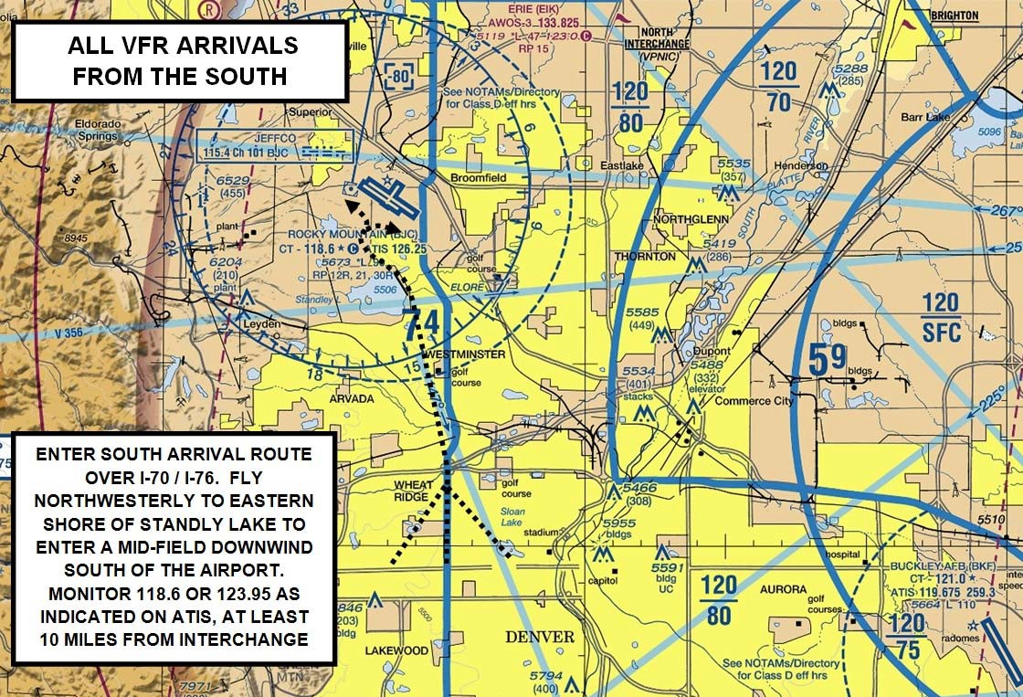
Diagram 3 –ALL BJC VFR Arrival Routing from South

Aircraft Parking
Separate parking areas will be designated for fly-in traffic, airshow traffic, aircraft vendors, and static displays. Final parking locations will be determined by ground personnel. Additional parking areas may be utilized for overflow purposes. Ramp Ops (and parking control) frequency is 120.425.

No Radio Operations
Due to heavy traffic during Airshow, “no-radio” operations are not permitted.

Departure Preparation
- No engine starts during Airshow times. Aircraft parked off of RWY 03/21 will require aircraft marshalling to start and taxi due to heavy pedestrian traffic. Do not start engine or taxi until ground handlers are available. Expect RWY 30R departure if conditions allow.

- First half hour after completion of Airshow, departures restricted to VFR only. No IFR.

Departure Procedures
- Monitor ATIS (126.25) for active runway. If departing after Airshow, do not start engine until
ATIS/Ground Control advises airport is open and you have ground handlers. Note – During airshow closure periods, movement of aircraft not participating in airshow prohibited.

- Ramp Ops provide services on frequency 120.425 for aircraft leaving parking area. Follow instruction of Ramp Ops and ground handlers to join Taxiway A and taxi to departure runway. Use caution for other aircraft entering taxiway, this area will not be controlled by Tower.

- Monitor Metro Ground Control (121.7) when you are on Taxiway A. Do not call Ground unless you need assistance or progressive taxi instructions.

- Complete any necessary run-up while taxiing. Tower will assume you are ready for takeoff upon your arrival at end of runway.

- Hold short of runway at approach end and monitor Tower for further instructions and/or departure clearance.

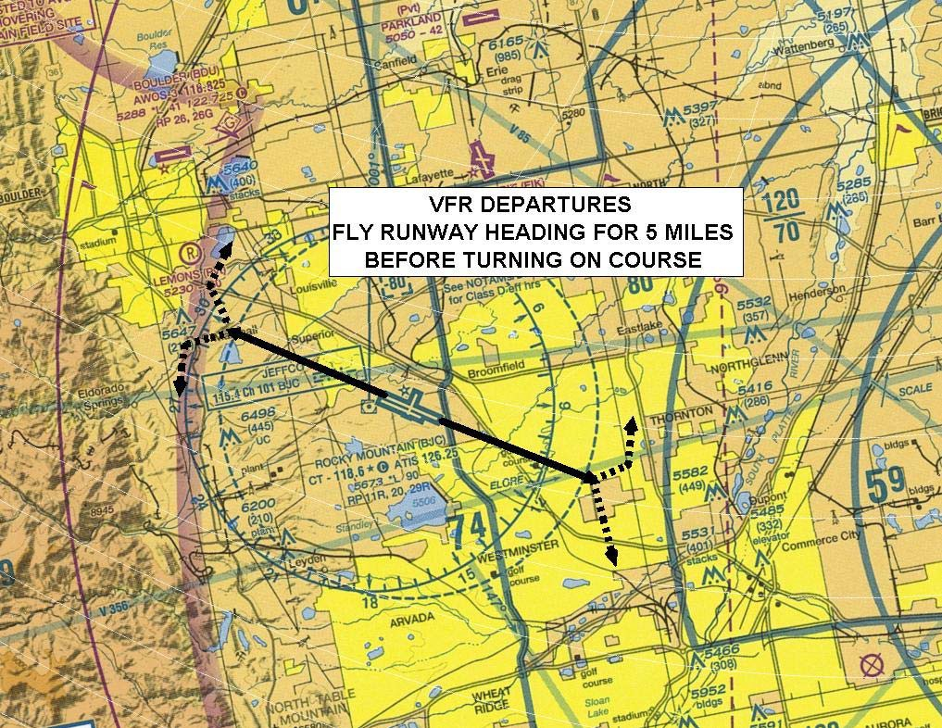
- All aircraft fly runway heading until 5 miles from BJC before turning on course.
Diagram 4 – BJC VFR Departure Routing

- Remember--floor of Denver’s Class B airspace begins at 8000 MSL directly east of BJC. You do not have a Class B clearance unless the controller explicitly tell you.

